# CSEN 383 – Assignment 1

# Winter 2024

### Chaitra Boggaram (W1651213)

## Working on MacOS

1. Be able to have reliable Linux environment

Running on an M2 MacBook

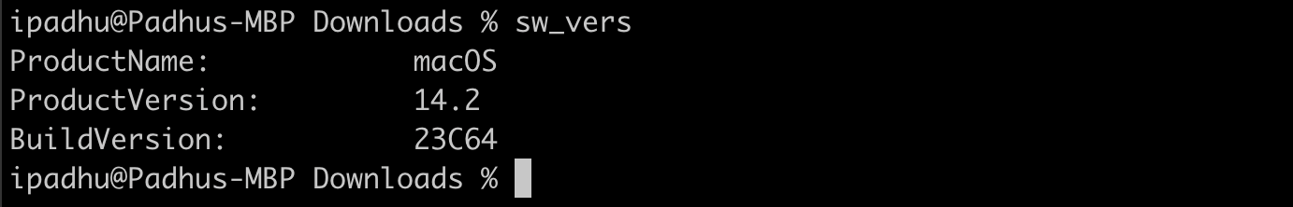

2. Compile and run the C program (forktest.c) on a Linux system and to

provide a screenshot of the compilation and execution.

gcc forktest.c -o forktest

forktest

3. Read the gcc man page

*I am running man clang because of the below explanations and gcc -v shows the clang version as provided in the below image.*

gcc -v

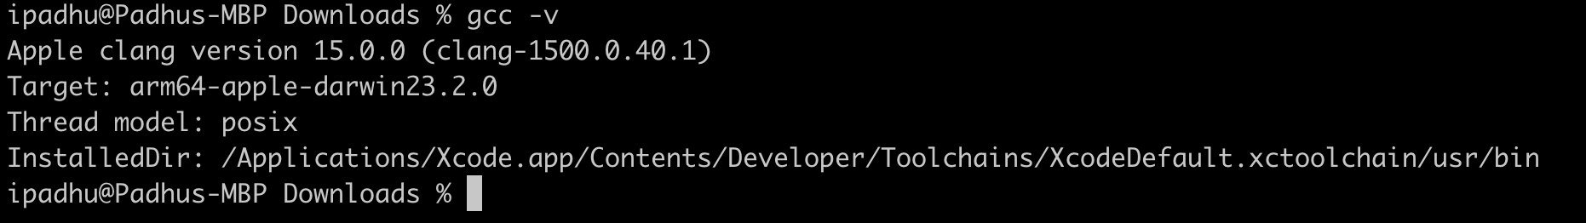

Apple uses Clang instead of GCC for a few reasons:

Speed and memory: Clang is faster and uses less memory than GCC.

Diagnostics: Clang provides clearer and more concise error and warning messages than GCC.

Language compliance: Clang has better language compliance than GCC, which improves compatibility with newer standards and languages.

Integration: GCC's large code doesn't integrate well with Apple's IDE.

Optimization and reliability: Clang is better than GCC for optimization and reliability because of LLVM.

Clang can replace GCC in many cases without affecting the toolchain. It supports most of the commonly used GCC options. However, for some languages, such as Ada, LLVM is still dependent on GCC or another compiler front end.

Apple doesn't ship a compiler with macOS or iOS, and doesn't want any user-compiled code to run. However, Xcode command-line developer tools include Clang.

**Reference:** [**https://www.incredibuild.com/integrations/clang#:~:text=The%20original%20contributor%20of%20Clang,IDE%20(Integrated%20development%20environment)**](https://www.incredibuild.com/integrations/clang#:~:text=The%20original%20contributor%20of%20Clang,IDE%20(Integrated%20development%20environment))

man clang

## Working on NoMachine (Linux machine from SCU)

1. Be able to have reliable Linux environment

Running on an Linux machine

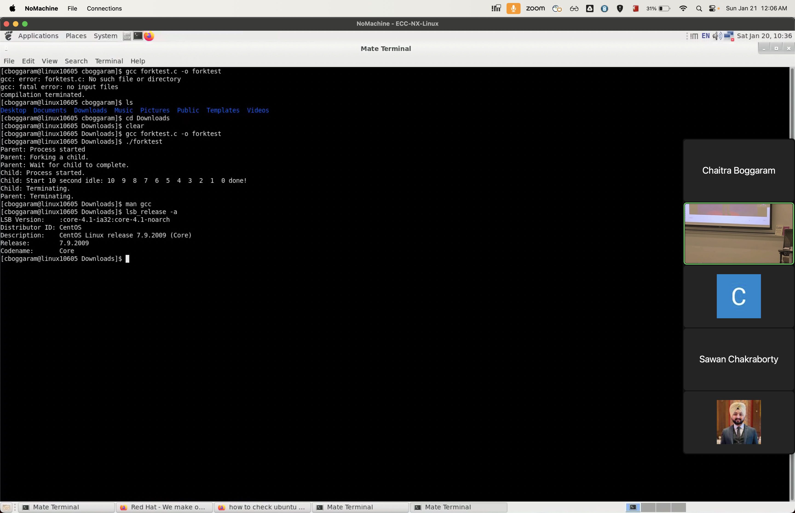

2. Compile and run the C program (forktest.c) on a Linux system and to

provide a screenshot of the compilation and execution.

gcc forktest.c -o forktest

forktest

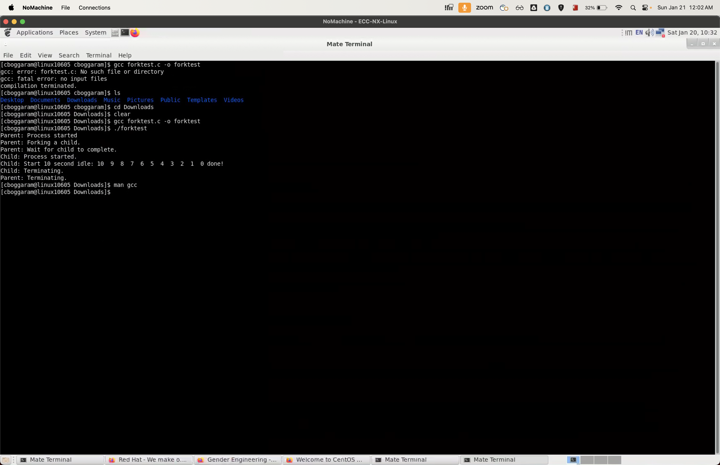

3. Read the gcc man page

man gcc

